OpenMP Threading Performance for Merge Sort Algorithm

Shashank Koundinya Cheruku
Graduate Student, Dept. of Computer Science
Texas Tech University
Lubbock, TX, United States
shashank-koundinya.cheruku@ttu.edu
Brindavani Sunkari
Graduate Student, Dept. of Computer Science
Texas Tech University
Lubbock, TX, United States
brindavani.sunkari@ttu.edu

Abstract— OpenMP provides a convenient, portable parallel programming methodology as an alternative to low-level constructs such as pthreads. Though, OpenMP directives provide parallel programming which is an efficient way to execute the program in parallel regions, use of such constructs may sometimes degrade the performance if care is not taken in placing the constructs. OpenMP runtime library implementers expend an arduous amount of effort to optimize the overheads that degrade the performance of the program. This overhead is majorly caused due to instantiating parallelism and collapsing them back to sequential execution. This can also be called as fork and join latency. In our project, we have implemented the parallel version of merge sort algorithm using sections and tasks and calculated the overhead associated with fork and join latency using a two-stage approach. We have compared the performances of these programs on different processors and also compared them using the cilksort program written specifically for the cilkplus compiler.
Keywords-openmp; cilksort; merge sort; cilkplus; performance; overhead;

Introduction

OpenMP:
OpenMP is an Application Programming Interface (API) that supports multi-platform shared memory multiprocessing programming in C, C++ and Fortran on most platforms, processor architectures and operating systems including Solaris, AIX, HP-UX, Linux, macOS and Windows. It consists of a set of compiler directives, library routines and environment variables that influence run-time behavior. It is the de-facto standard for portable, shared memory programming which provides single address/process space that supports all the programming languages and their respective compilers. It is a well-defined specification governed by OpenMP Architecture Board (ARB). The current version of OpenMP is 4.5 and the recent version 5.0 is under review by the board.
The advantage of using OpenMP over pthreads is its portability. It doesn’t limit the usage of code only to a single programming language, but can be used across other languages and platforms too. Another advantage of using OpenMP directives is that writing the code for pthreads can be a herculean task for the user with minimum knowledge about parallel programming, whereas, in the case OpenMP, we can utilize the compiler directives and clauses to parallelize the execution of the given code. The directives are to be preceded by the loop which is to be parallelized. The degree of parallelism can be controlled by the user by specifying the number of threads explicitly before the execution of the program.

Cilkplus:
Cilkplus is an extension to Cilk and Cilk++ which are the general-purpose programming languages designed for multithreaded parallel computing. They are based on the C and C++ programming languages, which they extend with constructs to express parallel loops and the fork-join policy. The principle behind the working of the Cilk language is that the programmer must only specify the elements that are to be executed in parallel and the rest scheduling of the parallelism should be left to the runtime environment. The Cilk scheduler executes on a policy called as “Work Stealing” which divides the procedure execution efficiently among multiple processors.
Cilk compiler is another implementation of parallel execution which was initially developed by Massachusetts Institute of Technology (MIT) and taken over by Intel Corporation. This compiler can be added as an extension to the C and C++ languages to support data and task parallelism. It is not just a library which contains a set of functions, but an extension to the compilers. For our project, we have implemented the Cilk compiler to test the performance of our programs on a different version of the compiler. We have also implemented a Cilksort program using the Cilk functions present in the library of the Cilk compiler. The advantages of Cilk compiler over OpenMP directives are:
- Fewer Keywords to remember
- Automatic load balancing
- Introduction of reducers to provide lock-free mechanism
- Lost cost spawning (good for high recursive code)

Problem Statement:
The threads initialized by the OpenMP directives have an overhead associated with instantiating parallelism and collapsing threads back to the sequential execution. This overhead is caused by the fork and join latency which differs from the initial startup latency. The overhead of the threads also varies if the same algorithm is executed using different OpenMP constructs.
For this project, we have implemented the Merge Sort Algorithm using the following constructs:
- Sections
- Tasks
We would like to explore the performance implications of the threads by calculating the overheads when implemented on different processors. We implemented the algorithms in two-stage approach and recorded the overheads. We also implemented the Cilksort Algorithm using the Cilk functions cilk_spawn and cilk_sync and compared the timing performance of this algorithm with the sections and tasks. We believe that this timing performance depicts the efficiency of parallelism of each algorithm.

Motivation:
The main intention behind choosing OpenMP Threading Performance as our major topic is to depict the degradation in the performance of the program with the increase in parallelization. Parallel execution of the program is generally done to increase the timing performance of the program. But, the overheads associated with the threads cause the delay in the execution which contrasts the use of parallel execution.
Sorting is one of the major technique that is used in basic programming to classify the data into required forms. Of all the sorting techniques, merge sort is found to be the efficient technique as it ahs linear running time in worst, best and average cases. So, we have chosen merge sort as the parallel solver to which OpenMP directives are to be applied. Another reason for choosing merge sort algorithm is that the OpenMP directives, sections and tasks, are especially good for algorithms that has non-deterministic data patterns like sorting techniques.
Combining the concepts of OpenMP and Merge Sort leads to an efficient algorithm which parallelly sorts the required data in linear time. According to the general definition of the OpenMP directives, the execution time of the algorithm should decrease with the increase in the number of threads. But, the overheads associated with the threads cause the threads to perform slower with the increase in the number of threads. So, through this project, we would like to check the difference in the timing performance of the overheads when executing on different processors.

BACKGROUND
^{[1]}Dr. Johnnie W. Baker, Professor of Computer Science and member of Parallel and Associative Computing Laboratory, Kent State University, has proposed an algorithm for the parallelized merge sort using the tasks OpenMP directive. But, in this algorithm, he didn’t consider the timing performance of the parallelized merge sort. He parallelized the execution of the merge sort on the small data and implemented memory functions to copy the data from temporary data arrays to the permanent location which is finally displayed as the sorted array in the main function. The major drawback of this approach is that when this approach is used on large datasets, the memory functions take a lot of time to copy the data. So, in our approach, we have just used the concept of parallelism and used pointers for the data exchange between functions where the use of temporary array can be discarded which saves a lot of memory in case of large datasets.
^{[2]}There are many implementations of the parallelized merge sort using the sections OpenMP directives. Of all the available implementations, a nearest implementation to that of our implementation is the one available in the GitHub repository of Mr. Chris. He has implemented the sections merge sort in C++ which we have taken as the reference for our algorithm. We have implemented our algorithm in C as we have compared the timing performance of this algorithm with cilksort program that was implemented in the C language. In the approach present in the GitHub repository, the algorithm was written separately for sequential and parallel execution which increases the lines of code and decreases the efficiency. For our approach, we have initially supplied the number of threads as the command line arguments and created the array size used for measuring the running time based on the number of threads. Furthermore, this algorithm also used the temporary arrays which we overcame with the help of pointers.
^{[3]}Selim G. Akl and Nicola Santoro, in their paper, Optimal Parallel Merging and Sorting Without Memory Conflicts, depicted a parallel merge sort algorithm that doesn’t have any sort of memory conflicts and has less running time than the regular merge sort. This paper depicted the selection algorithm that is a part of the merge sort and it runs on a shared memory model of parallel computation that disallows more than one processor to simultaneously read from or write into the same memory location. This algorithm, in the future, after the introduction of the Cilk language was depicted as the Cilksort algorithm. For our paper, we have implemented a new cilksort algorithm in a two-stage parallel approach by considering the algorithm in this paper as the base algorithm.
^{[4]}Dr. Johnnie W. Baker, Professor of Computer Science and member of Parallel and Associative Computing Laboratory, Kent State University, has depicted the cilksort algorithm using the Optimal Parallel Merging and Sorting Without Memory Conflicts paper as the base paper for developing the cilksort program. But, in this algorithm, the timing performance was calculated based on the number of ticks which may be delayed while the execution of the algorithm is calculated using the functions in the time header file.
Finally, we have implemented the sections and tasks algorithm initially on three different processors for calculating the timing performance of the overheads. Then, we have implemented the cilksort, sections and tasks using the similar timing functions and calculated the efficiency of the algorithms when executed using the Cilk compiler.

TECHNICAL APPROACH
In this project, we have implemented a two-stage parallel algorithm approach and record the overhead associated with the OpenMP runtime using different directives. This two-stage approach permits us to separate the fork and join latency from the initial startup latency of the threads.
We utilized two different implementations of OpenMP constructs for the same algorithm to test the performance of each of the implementation. The implementations we have used are:
- Sections
- Tasks
The pragmas sections and tasks have been implemented before the functions for which the parallel execution is implemented. We have implemented the two-stage approach for a scaled number of threads from 1 to 2*N (where N is the no. of cores in the system). We have provided oversubscription of the threads i.e. provide more number of threads to the program than the number of cores. We have used 3 different processors to execute the following programs:
Processor | Operating System | Compiler
Twelve-Core AMD Opteron Processor @ 1.8GHz  64GB Memory | Ubuntu 16.04 LTS  Kernel: 4.4.0-66-generic | gcc 5.4.0 2016609
Sixteen-Core Intel Xeon CPU E5-2650 @ 2.6GHz  64GB Memory | CentOS Release 6.5  Disci.hpcc.ttu.edu | gcc 4.4.7 20120313
Dual-Core Intel Core i5-2410M CPU @ 2.30GHz  4GB Memory | Ubuntu 16.04.2 LTS | Cilkplus compiler  gcc 4.9.0 20130520

In this section, we would like to explain the important snippets from 6 different code files that we have implemented to test the performance of the OpenMP directives.

Openmp_sections.c
This file contains the sections OpenMP directives that are applied to the merge sort algorithm. In the main function of the code, the parallel section is written as:

start = omp_get_wtime();
#pragma omp parallel
{
alg_start[omp_get_thread_num()] = omp_get_wtime();
merge_sort(data,0,SIZE-1);
alg_end[omp_get_thread_num()] = omp_get_wtime();
}
end = omp_get_wtime();
max = find_max(alg_end,tnum);
min = find_min(alg_start,tnum);
printf("Stage 1 total runtime = %f\n",end-start);
printf("Stage 1 alg runtime = %f\n",max-min);
printf("Stage 1 overhead = %f\n",(end-start)-(max-min));

The above code is written in the main function of the sections program. Here, the start variable records the starting time of the algorithm before the forking is done at the parallel region. Then, the execution of the parallel region is started and the alg_start[] array records the starting time of all the threads. Then, the algorithm merge_sort() is executed and then the alg_end[] array records the ending time of all the threads. Now, after the execution of the algorithm, the joining of all the data takes place at the closing brace of the parallel region. Then, the end variable records the ending time of the algorithm. Now, the max and min variables store the maximum value of alg_end array and the minimum value of alg_start array using the find_max and find_min functions respectively. The total runtime and the algorithm runtime are differentiated because there is some time loss during the forking and joining of the parallel region. This difference in the runtime is calculated as the overhead time. So, the overhead is calculated as (end-start)-(max-min). Thus, the overheads are calculated for two stages and the average of the overheads is calculated for 1 to the 2*N number of threads. The two-stage approach is taken so that there is a chance of the presence of the initial startup latency which can be reduced in this approach.

void merge_sort(int *x,int p,int r){
if(p<r){
int q=(p+r)/2;
#pragma omp parallel sections
{
#pragma omp section
merge_sort(x,p,q);
#pragma omp section
merge_sort(x,q+1,r);
}
merge(x,p,q,r);
}
}

The above code is the merge_sort() function for which the parallel region is implemented. The outer loop #pragma omp parallel sections specifies that the code below is implemented in the form of multiple sections and all the sections are written inside this region. Then, inner directive #pragma omp section is written for each of the merge_sort() function which are called recursively. This pragma states that the execution of each function is given to a single thread when section is specified. The ending brace of the outer loop acts as a mutex lock so that the execution of the threads is completed before the execution of the merge() function.

Openmp_tasks.c
This file contains the code for the tasks program execution of the merge sort algorithm. The main function of the code is similar to that of the openmp_sections.c where two-stage approach is used for the overhead calculation. The difference in the code occurs in the merge_sort() function:

void merge_sort(int *x,int p,int r){
if(p<r){
int q=(p+r)/2;
#pragma omp task firstprivate(x,p,q)
merge_sort(x,p,q);
#pragma omp task firstprivate(x,q,r)
merge_sort(x,q+1,r);
#pragma omp taskwait
merge(x,p,q,r);
}
}

The above code represents the merge_sort() function in the tasks program. The directive #pragma omp task firstprivate() is specified before each of the recursive call of the merge_sort() function. This pragma makes sure that each function is given to a thread which has the private variables specified in the firstprivate(). The difference between the sections and tasks execution is that if a thread executes faster than the other thread in the tasks, then one of slower threads passes its remaining execution to the faster thread. But, in the case of sections, when a section is assigned to a specific thread, the function is executed only by that thread irrespective of the execution time of the thread. So, tasks implementation is faster than the sections implementation. The directive #pragma omp taskwait works as the mutex lock which makes sure that the execution of all the threads is done before the merge() function is executed.

Cilk_sort.c
This program is the cilksort implementation of the merge sort algorithm. The main function in this program is written as:

gettimeofday(&start,NULL);
merge_sort(data,0,SIZE-1);
gettimeofday(&end,NULL);
run_time = (end.tv_sec+(double)end.tv_usec/1000000) -(start.tv_sec+(double)start.tv_usec/1000000);
printf("Stage 1 alg runtime in seconds = %lf\n",run_time);

First, the starting time of the algorithm is stored in the start variable using the gettimeofday() function. Then, the merge_sort() function is executed and the ending time is stored in the end variable. Then, the runtime of the algorithm is calculated as the end-start. This execution is again implemented in two-stages to decrease the initial startup latency. Now, the merge_sort() function in this program is written as follows:
void merge_sort(int *x,int p,int r){
if(p<r){
int q=(p+r)/2;
cilk_spawn(merge_sort(x,p,q));
cilk_spawn(merge_sort(x,q+1,r));
cilk_sync;
merge(x,p,q,r);
}
}

The function cilk_spawn(), which is present in the <cilk.h> header file is written for the recursive calls of the merge_sort(). This cilk_spawn() function automatically assigns a single function to a single thread while maintaining the concept of load balancing. This is the major advantage of the cilksort program. The cilk_sync is used to make sure that all the execution of the threads are done before the call of the merge() function. We can observe that the implementations of different versions of merge sort are similar to each other. But, the difference occurs in the runtime execution of each program. The results of the execution times are explained in coming sections.
The execution of the cilksort program requires the Cilkplus compiler to be installed. This compiler extension includes the header files and the library files required to implement the cilksort algorithm. So, we have implemented this algorithm only on one processor i.e. Intel Dual Core i5 and also the comparison programs described below.

Sections_compare_cilk.c and Tasks_compare_cilk.c
The code of the main function of these programs is similar to that of the combination of the cilksort program as well as the sections and tasks program which records the running time of the algorithms in two-stage approach. The parallel implementation is taken from the section and tasks and the timing performance is recorded using the functions written in the cilksort program. The merge_sort() functions are similar to that of the sections and the tasks program. These programs are implemented so as to compare the timing performance of the cilksort with the sections and the tasks implementation.

Runbench.sh
This is a shell script file written in order to automate the generation of outputs for each file. The code of this file is as follows:
#!/bin/bash
MAX=5
TH=1
while [ $TH -lt $MAX ]; do
export OMP_NUM_THREADS=$TH
echo "NUM_THREADS=$OMP_NUM_THREADS"
touch openmp_sections.$TH.txt
./openmp_sections.exe >> openmp_sections.$TH.txt 2>&1
sleep 2
touch openmp_tasks.$TH.txt
./openmp_tasks.exe >> openmp_tasks.$TH.txt 2>&1
sleep 2
TH=$[$TH+1]
done

Initially, the MAX variable is set to one greater than the maximum number of threads that can be executed in the processor. Then, in the while loop, the export statement is called to set the number of threads for parallel execution. Then, the echo statement prints the number of threads that are being currently used for execution. Then, a text file is created for current number of threads execution and the output is stored in the text files. Similarly, this is done for the tasks execution too after the execution of the sleep function for about 2 seconds. Then, the thread number is incremented by 1 and the loop is executed until it reaches the maximum number of threads.

DISCUSSIONS
This section concentrates on the comparison of the overheads calculated on different processors for different programs. We have provided three different analyses, each for sections, tasks and comparison of OpenMP directives with Cilksort algorithm. Initially, we have provided the sample output retrieved from the runbench.sh program.

Sample Output
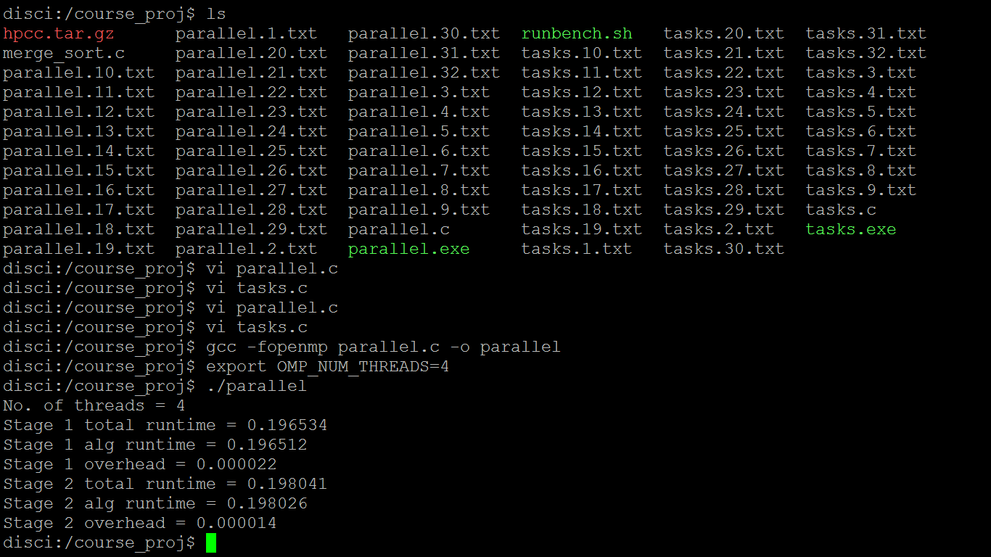

We can observe in the above figure that there are many text files named as parallel.1.txt to parallel.2.txt and tasks.1.txt to tasks.2.txt. This output has been retrieved from the HPCC server, so, we get 32 text files for parallel and tasks programs as the programs were run for 1 to 32 threads.
Below, we can observe a sample output for the sections program when executed for 4 threads. We can see that the total runtime, algorithm runtime and the overhead has been calculated for two stages. This output is saved in parallel.4.txt and similarly, all the other files contain the outputs for the executed number of threads.

Section Program Analysis
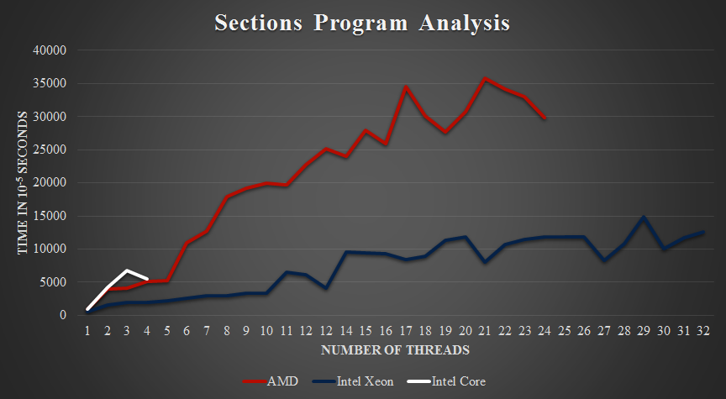

The above graph depicts the overhead for 1 to maximum number of threads for three different processors. The red line represents the AMD processor, the blue one is the Intel Xeon HPCC processor and the white line represents Intel Dual Core processor. We can observe that the overhead increases with the increase in the number of threads. Though the scale of overhead is taken in the power of 10⁻⁵ seconds, this overhead can be strenuous when a set of such programs are implemented in a project.

Tasks Program Analysis
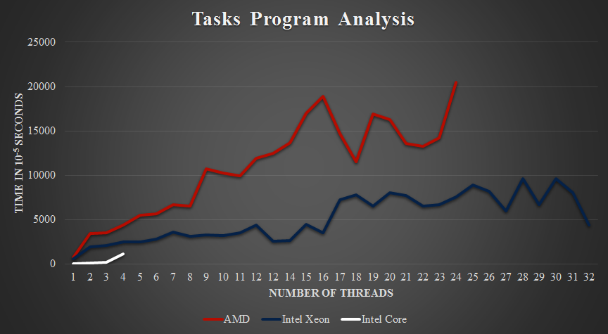

The above graph depicts the overhead performance for different number of threads for three different processors. We can see in this graph that the overhead increases with the increase in number of threads with some little deviations. But, we can observe that the time range is little less i.e. the range of overheads for tasks program is [0,25000], whereas, for the sections program, it is [0,40000]. So, we can conclude that the tasks program has less overhead than the sections program.

Cilk vs OpenMP
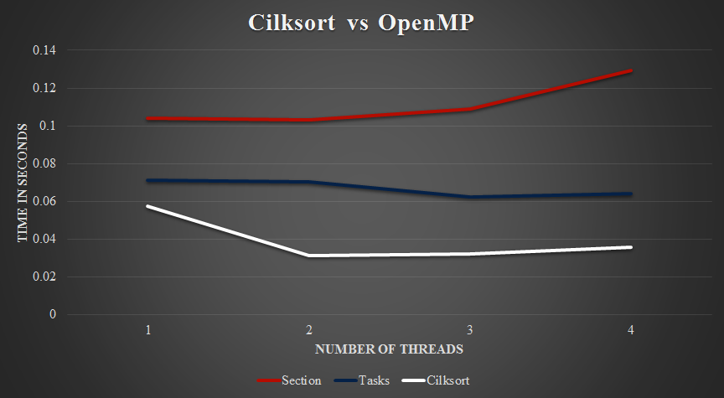

The above graph depicts the performance implications of the cilksort when compared with the merge sort with OpenMP directives. We can observe that the sections program, which is depicted as the blue line in the graph, has the highest running time of all the three algorithms. We can also observe that the running time increases with increase in threads due to overheads. The running time of the task program is very close to that of the cilksort program but the cilksort has the least running time of all the three algorithms. So, we can predict that as the cilksort has least running time, it also has less overhead than the section and tasks programs.

CONCLUSIONS
- The overhead associated with the threads increases with the increase in the number of threads.
- More threads means more management activities by the runtime software. So, we observe the increase in overhead as the number of threads increases.
- Another reason for the increase in overhead is due to the scaling issues of the merge sort algorithm for large datasets as the overhead is used to maintain parallelism which is larger than the overhead of actual computational kernel.
- Task algorithm performs better than the sections algorithm as it has less overhead associated with it.
- Cilksort comparatively performs better than the OpenMP algorithms.
We have uploaded the source codes, final report and graphs to our GitHub repository which can be viewed from here:
OpenMP Threading Performance for Merge Sort Algorithm

FUTURE WORK
- Overheads can be calculated for the Cilksort algorithm and compared with the overhead associated with the OpenMP algorithms.
- A more efficient algorithm can be developed to decrease the overheads.
- Performance implications of the cilksort can be calculated among different operating systems.

ROLES AND RESPONSIBILITIES
Shashank Koundinya Cheruku:
- Conducted initial research about the project topic.
- Analysis of different algorithms and their findings.
- Installing the beta version of the Cilkplus compiler, implementation of the new sorting algorithm called “Cilksort” and findings.
- Major part of the report writing.
Brindavani Sunkari:
- Implementation of the sections and tasks programs.
- Part of the report writing.
- Preparation of presentation slides.

Acknowledgment
This research paper was published as a part of Course Project for the Advanced Operating Systems Design class in Spring 2017. We thank Dr. Yong Chen, Assistant Professor, Department of Computer Science, Texas Tech University, for offering this project and guiding us throughout our work.
We would also like to thank our supervisor, Mr. John Leidel, PhD Student, Texas Tech University, for his patient guidance, encouragement and advice he has provided throughout the commencement of the project.
Finally, we would like to thank our Teaching Assistant for this course, Mr. Wei Zhang, for his undeniable support in maintaining and resolving issues with the HPCC server for our project execution.

References
- Johnnie W. Baker, http://www.cs.kent.edu/~jbaker/23Workshop/Chesebrough/mergesort/mergesortOMP.cpp
- Chris, https://github.com/serendependy/parallel-j/blob/master/OpenMP/mergeSort-omp.c
- Selim G. Akl and Nicola Santoro, “Optimal parallel merging and sorting without memory conflicts”, IEEE Transactions on Computers, Vol. C-36, 11 Nov, 1987.
- Johnnie W. Baker, http://www.cs.kent.edu/~jbaker/23Workshop/Chesebrough/mergesort/mergesortCilk.cpp
- https://www.cilkplus.org/
- http://www.openmp.org/
- https://en.wikipedia.org/wiki/OpenMP
- https://en.wikipedia.org/wiki/Cilk

